3 Hairstyles That COULD BE Making You Look Old ~ and the alternatives to try instead.
The way you wear your hair can have a great effect on how young (or old) you look. While some styles can be too harsh, others can add on years without you even realizing it. Here are three hairstyles that could be aging you, and why and a suggestion for a more youthful counterpart to try instead.
The Blunt Lob vs. The Layered Lob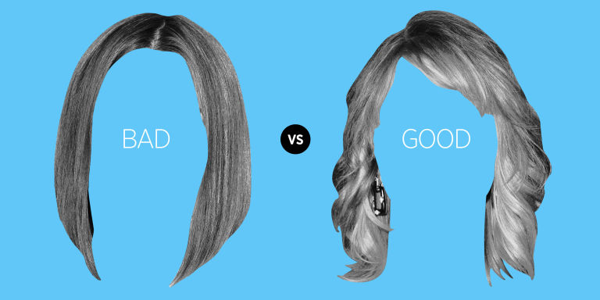
When you age, you lose the youthful plumpness in your face, so you don't want a look that highlights any harsh angles. The hairstyle on the left is very severe, while the hairstyle on the right has subtle side-swept bangs that soften the forehead, as well as layers that frame the face, making it appear fuller and fresher.
Bottom Heavy vs. Top Heavy 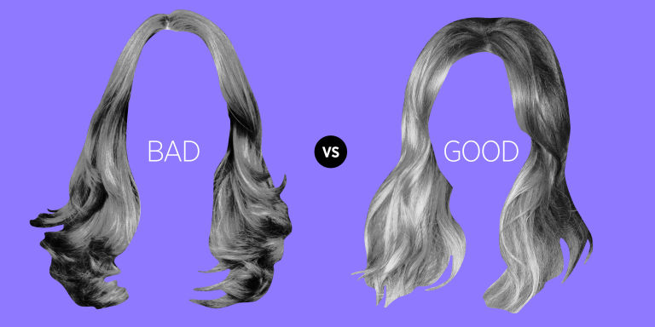
Droopy eyes and sagging skin are definite signs of aging, and bottom-heavy hair can drag your face down, too, and add years to your look, making your face appear droopy overall. The style on the left has layers only at the ends of the hair and is flat at the top. The look on the right is lighter and has volume throughout, and even a little extra height at the crown to bring the attention upward, making the face appear more awake and youthful.
Stick Straight vs. Natural Waves
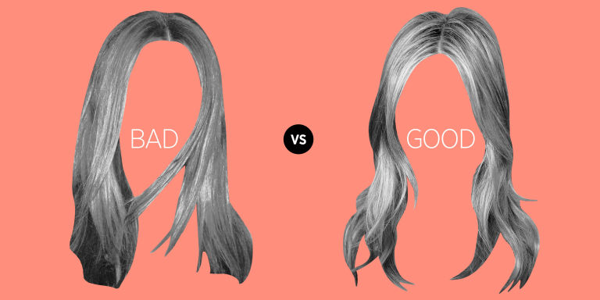
Pin-straight hair can harden your face and accentuate every fine line especially if it is really long. Subtle waves, like on the right, create more movement and will add buoyancy and life to your look. If you must keep it straight, though, just try a shorter length that falls somewhere between your shoulders and collar bone.

